Exercise 1:
- List 5 examples of software errors related to: loss of money, time, or business reputation, injury or death…. Explain.
- What is software testing. Definition of software testing from ISTQB
- Difference between verification and validation. Give example.

CONTENTS
QUESTION 1 FIVE EXAMPLES OF SOFTWARE ERRORS 3
1.1 Banking Software Error – Loss of Money 3
1.2 Airline Reservation System Failure – Loss of Time and Business Reputation 3
1.3 Hospital Software Error – Injury or Death 3
1.4 E-commerce Website Error – Loss of Reputation and Revenue 3
1.5 Traffic Control System Failure – Accidents and Property Damage 4
QUESTION 2 5
2.1 What is Software Testing? 5
2.2 ISTQB Definition of Software Testing 5
2.3 Simple explanation 5
QUESTION 3 6
3.1 Verification 6
3.2 Validation 6
3.3 Comparison Table 8
3.4 Concrete Example: Building a Smartwatch 9
3.5 Summary 9

QUESTION 1 FIVE EXAMPLES OF SOFTWARE ERRORS

Banking Software Error – Loss of Money

Example:
An online banking system has an error in the money transfer function. When a customer transfers 5 million VND, the system accidentally transfers 50 million VND or sends the money to the wrong account.

Explanation:
This error may happen because of incorrect algorithms, database problems, or transaction processing failures. As a result, customers may lose money, and the bank may need to compensate for damages. If the problem affects many customers, the financial loss can be very serious.

Airline Reservation System Failure – Loss of Time and Business Reputation

1.2.1. Example:
An airline booking system crashes during a holiday season, preventing passengers from booking tickets or checking in.

Explanation:
When the software stops working, customers must wait for a long time or may miss their flights. This causes inconvenience and damages the airline’s reputation. The company may also lose revenue because customers choose other airlines.

Hospital Software Error – Injury or Death

Example:
A hospital system displays the wrong blood type or incorrect medicine dosage for a patient.

Explanation:
Doctors depend on system information to provide treatment. If the information is wrong, patients may receive incorrect medicine or blood transfusions. This type of error is extremely dangerous because it can cause serious injury or death.

1.4 E-commerce Website Error – Loss of Reputation and Revenue

1.4.1. Example:
An online shopping website displays the price of a smartphone incorrectly, such as showing $1,000 as $100, or loses customer orders.

1.4.2. Explanation:
Customers may lose trust in the company because the system appears unreliable. The company may suffer financial loss from incorrect pricing and lose customers due to poor service. Negative feedback on social media can also seriously damage the company’s reputation.

1.5 Traffic Control System Failure – Accidents and Property Damage

1.5.1 Example:
A traffic light control system malfunctions and shows green lights in both directions at the same time.

1.5.2 Explanation:
Vehicles from different directions may move at the same time and crash into each other. This can cause traffic accidents, injuries, deaths, and property damage. Errors in traffic systems are very dangerous because they directly affect human safety.

QUESTION 2

2.1 What is Software Testing?
Software testing is the process of evaluating and checking a software application to ensure that it works correctly and meets the specified requirements. The main purpose of testing is to find defects, improve quality, and ensure the software behaves as expected.

2.2 ISTQB Definition of Software Testing
According to International Software Testing Qualifications Board (ISTQB):
“Testing is the process consisting of all life cycle activities, both static and dynamic, concerned with planning, preparation and evaluation of software products and related work products to determine that they satisfy specified requirements, to demonstrate that they are fit for purpose and to detect defects.”

2.3 Simple explanation
Software testing includes all activities used to:
- Check whether the software meets requirements
- Detect defects or bugs
- Ensure the software is suitable for users’ needs
- Improve software quality throughout the development life cycle

QUESTION 3
In software engineering, Verification and Validation (often referred to as V&V) are the two pillars of software quality control. While they sound similar, they address different aspects of the development process.
The simplest way to remember the difference is:
- Verification: "Are we building the product right?"
- Validation: "Are we building the right product?"

3.1 Verification
Verification is the process of evaluating software artifacts (requirements, design, code) during the development phases to ensure that the product is being built according to the specified requirements and technical standards.
- Timing: Occurs throughout the development process (before Validation).
- Activities: Code reviews, document inspections, walkthroughs, and desk-checking.
- Form: Usually Static Testing—the software is not actually executed. It focuses on the "blueprints."

3.2 Validation
Validation is the process of evaluating the final product (or a functional version of it) to ensure that it meets the actual needs and expectations of the customer and the end-user.
- Timing: Occurs after the Verification of a specific stage or at the end of the development cycle.
- Activities: Functional testing, performance testing, and User Acceptance Testing (UAT).
- Form: Usually Dynamic Testing—the software is executed to see if the outputs match the real-world requirements.
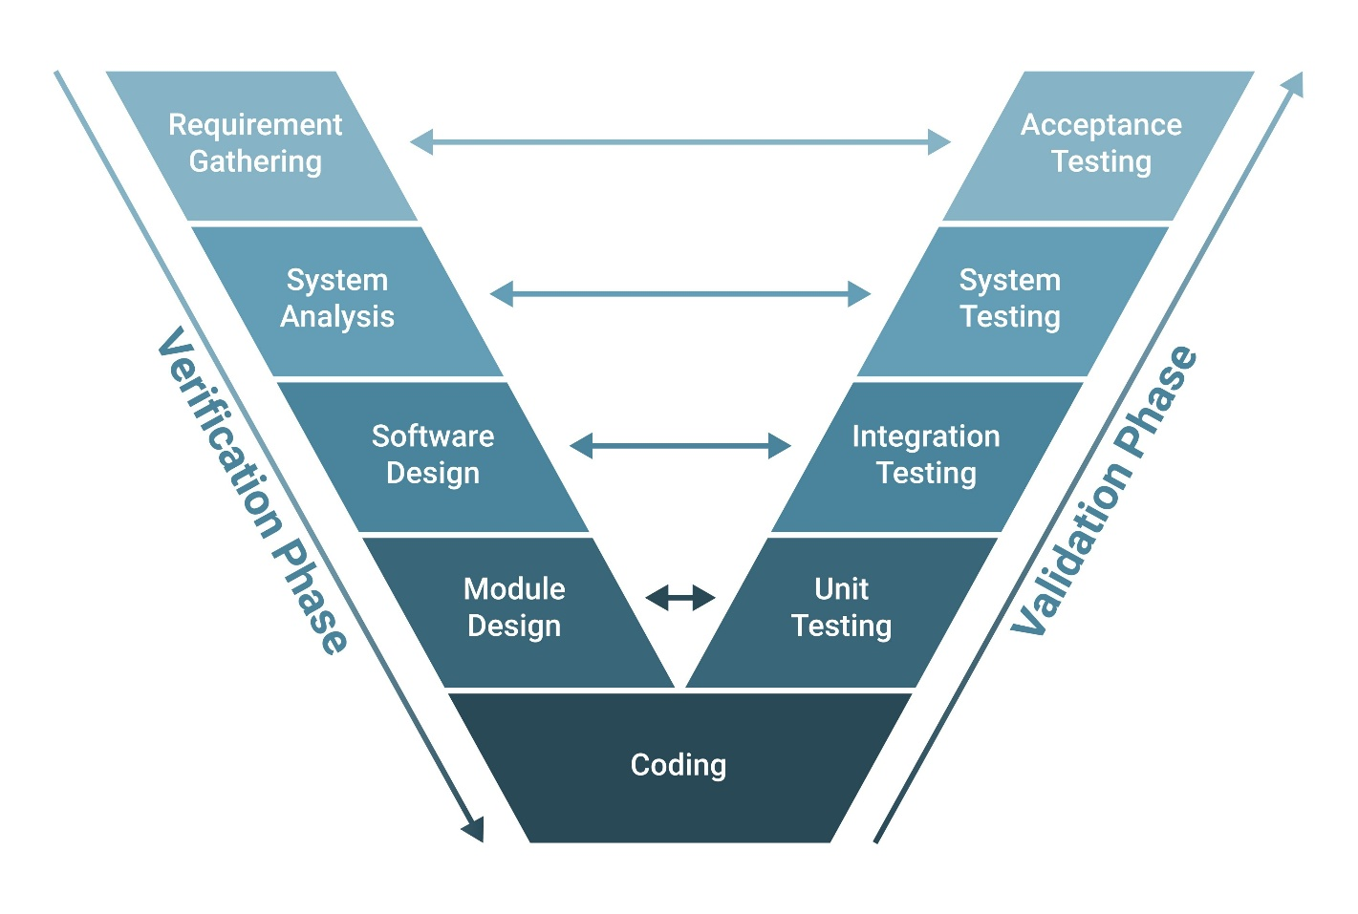
Shutterstock

3.3 Comparison Table
Feature | Verification | Validation
Objective | Ensure compliance with design and specs | Ensure customer satisfaction and needs
Focus | Process-oriented (The "How") | Product-oriented (The "What")
Method | Static (Reviews, Inspections) | Dynamic (Execution of code)
Performed by | Developers and QA teams | Testers and End-users/Stakeholders
Typical Tasks | Verifying documents, logic, and code | Testing the actual system against user goals

3.4 Concrete Example: Building a Smartwatch
Imagine you are developing a Waterproof Smartwatch for Divers.
The Verification Stage:
- The Task: Engineers check the design documents. Does the casing meet the "IP68 waterproof" technical specification? Does the code for the depth sensor follow the math logic defined in the requirements?
- The Check: You verify that the watch is built exactly as the blueprints instructed.
- Result: The watch passes verification because it is built right (it follows the plan).
The Validation Stage:
- The Task: You give the prototype to a professional diver and ask them to use it in the ocean.
- The Feedback: The diver says, "The buttons are too small to press while wearing thick diving gloves, and the screen is impossible to read in murky water."
- Result: The watch fails validation. Even though it was built perfectly according to the technical specs (Verification), it is not the right product for the user's actual needs.

3.5 Summary
You need Verification to ensure the code is clean, logical, and follows the plan. You need Validation to ensure that once the code is finished, it actually solves the user's problem. A product can pass verification but fail validation, and vice versa—successful software requires both.

